|  |  |  |
| --- | --- | --- |
|  | **PHYS 102 General Physics II – Midterm 1**  **March 09, 2016 Wednesday 19:00 -?** |  |

**Please read!**

* Count to make sure that there are 5pages in the question booklet
* Check your name and surname on front page, and student ID number on each page, and sign each page.
* This examination is conducted with closed books and notes.
* Put all your personal belongings underneath your seat and make sure that pages of books or notebooks are not open.
* Absolutely no talking or exchanging anything (like rulers, erasers) during the exam.
* You must show all your work to get credit; you will not be given any points unless you show the details of your work (this applies even if your final answer is correct!).
* Write neatly and clearly; unreadable answers will not be given any credit.
* If you need more writing space, use the backs of the question pages and put down the appropriate pointer marks.
* Make sure that you include units in your results.
* Make sure that you label the axis and have units in your plots.
* You are not allowed to use calculators during this exam.
* Only the answers in the boxes will be graded and NO partial credit will be given. No points will be given to unjustified answers. Incomplete calculations will not be graded.

**P102_Index:**

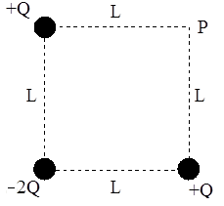**1- (25 pts)** Consider the three point charges that are positioned at the corners of a square as shown in the figure. Give your results in terms of **Q**, **L** and .

(a) Find the **x** and **y** components of the **total electric field vector** at the empty corner **P**?

(b) Find the **x** and **y** components of the **total force vector** on the point charge **-2Q**?

|  |
| --- |
| (a)  =  =  (b) =  = |

Description: Macintosh HD:Users:miskin:Desktop:mt2.eps**2- (25 pts)** Assume the entire **yz**-plane (that is the plane perpendicular to the plane of this paper) is uniformly charged with a surface charge density = **C > 0**, and a uniformly charged spherical insulator with radius **R** is positioned away from the plane at a distance of **3R**. Assume the coordinates for the center of the sphere is (**x = 3R**, **y = 0**).

If the total electric field is measured to be **0** at (**x = 4R**, **y = 0**) then

(a) first find the volume charge density  of the sphere

(b) and then find the **x** and **y** components of the total electric field vector at (**x = 3R**, **y = R/2**).

|  |
| --- |
| (a) =  (b)=    = |

Give your results in terms of **C**, **R** and **.**

**3- (25 pts)** Only the answers in the boxes will be graded and NO partial credit will be given. No points will be given to unjustified answers. Incomplete calculations will not be graded.

(a) How much energy (in mili-joules, mJ) is needed to place +1 C charge at each corner of an equilateral triangle with sides of length 0.25 m? (k = 1 / 40 = 9 x 109 Nm2 / C2, 1  -6)

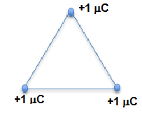

(b) Consider four points A, B, C, and D whose geometrical locations correspond to the corners of a square with sides of length 1 mm. Calculate the potential differences (in mV) VAB, VBA, VAC, VCA, VAD, VDA, VBC, VCB, VBD, VDB, VCD, VDC between the points in a uniform electric field of 3 V/m parallel to the two sides (and perpendicular to the other two) of the square.

VAB= VBA=

VAC= VCA=

VAD= VDA=

VBC= VCB=

VBD= VDB=

VCD= VDC =

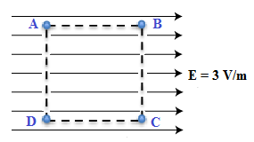

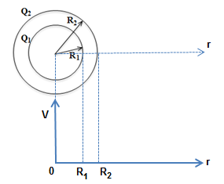(c) Two thin concentric spherical metal shells of radius R1 and R2 with R2 > R1 carry charges Q1 and Q2, respectively. The charge of the outer shell Q2 < 0 is greater than the inner shell charge Q1 > 0 in magnitude (|Q2| > Q1). Plot how the potential behaves as a function of radial distance r qualitatively by using physical arguments for every region.

(i) 0 r R1,

(ii) R1 r R2, and

(iii) R2 r .

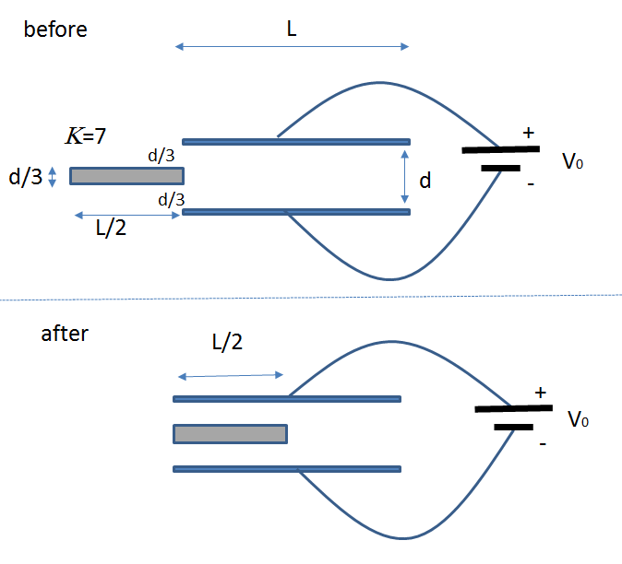**4- (25 pts)** A paralel-plate capacitor is constructed from two square plates of sides L and seperation d. Initially the space between plates contains only air (  0) The capasitor is charged by a batery providing constant voltage V0. A material of dielectric constant =7 is inserted into the capacitor as shown in the figure.

(a) Find the capacitance of the device before and after the dielectric was inserted.



(b) Calculate the total charge on the capacitor before and after the dielectric was inserted.



(c) Canculate the enery stored on the capacitor before and after the dielectric was inserted.

