|  |  |  |
| --- | --- | --- |
|  | **PHYS 102 General Physics II – Midterm II** **April 18, 2016 Wednesday 19:00 -20:30** |  |

**Please read!**

* Count to make sure that there are 5pages in the question booklet
* Check your name and surname on front page, and student ID number on each page, and sign each page.
* This examination is conducted with closed books and notes.
* Put all your personal belongings underneath your seat and make sure that pages of books or notebooks are not open.
* Absolutely no talking or exchanging anything (like rulers, erasers) during the exam.
* You must show all your work to get credit; you will not be given any points unless you show the details of your work (this applies even if your final answer is correct!).
* Write neatly and clearly; unreadable answers will not be given any credit.
* If you need more writing space, use the backs of the question pages and put down the appropriate pointer marks.
* Make sure that you include units in your results.
* Make sure that you label the axis and have units in your plots.
* You are not allowed to use calculators during this exam.
* Only the answers in the boxes will be graded and NO partial credit will be given. No points will be given to unjustified answers. Incomplete calculations will not be graded.

**P102_Index:**

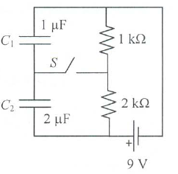**1- (25 pts)** Consider the DC circuit shown in the figure. Determine the final value of the charges in each capacitor separately for the case when

(a) the switch *S* is open (as in the figure) and a long time passed, and

(b) the switch *S* is now closed and a long time has passed in this setting.

Note: *micro* means *1/1000000* and *kilo* means *1000*; give numerical values, do not forget to include the units.

|  |
| --- |
| (a)  =  =  (b)  =  = |

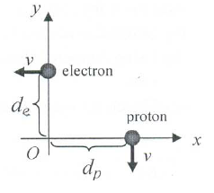**2- (25 pts)** At the instant shown in the figure, an electron and a proton are moving in perpendicular paths with the same speed *v*. Find the total electric and magnetic force (vector) the electron exerts on the proton at this instant. Denote the charge for electron and proton by *-e* and *e*, respectively.

|  |
| --- |
| = |

Only the answers in the boxes will be graded and NO partial credit will be given. No points will be given to unjustified answers. Incomplete calculations will not be graded.

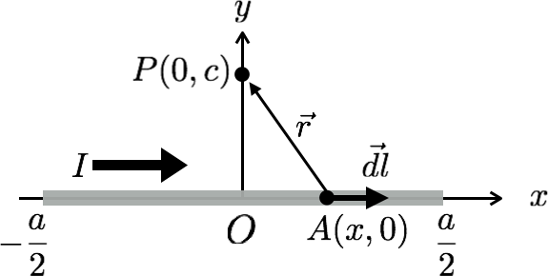

**3- (25 pts)** Consider a wire segment of length $a$, which carries a steady current $I$, as shown in the figure. For the coordinate system given in the figure answer the following questions:

(i) Express the length element $\vec{dl}$ at point $A(x,0)$ in terms of the unit vectors $(\hat{i},\hat{j})$ and the differential displacements $\left(dx,dy\right)$ of the coordinate system.

(ii) Express the vector $\vec{r}$ from point $A$ to point $P$ in terms of the unit vectors $(\hat{i},\hat{j})$ and the coordinates of $A$ and $P$. Calculate the magnitude $r$ of $\vec{r}$.

(iii) Calculate the cross product $\vec{dl } × \vec{r}$.

(iv) Calculate the magnetic field at point $P$ using the law of Biot-Savart. You may use the following indefinite integral in your calculation: $$\int{\frac{dx}{{\left(x^{2}+q\right)}^{\frac{3}{2}}}}=\frac{x}{q{\left(x^{2}+q\right)}^{\frac{1}{2}}}+constant$$

(v) Using your answer to (iv), calculate the magnetic field at the center of a ring of radius $R$ carrying a steady current $I$. (Hint: A circle can be obtained from an $n$-sided regular polygon as $n→∞$.)

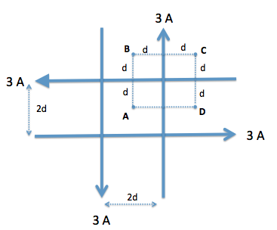**4- (25 pts)** Four very long current-carrying wires (I=3 A) in the same plane intersect to form a square, as shown in the Figure. Find the magnitude and the direction of the net magnetic fields at points A, B, C and D.

Magnitude Direction

Point A:

Point B:

Point C:

Point D